AM000-Asia-Japan-Mirror-Edo-Cranes and Tree

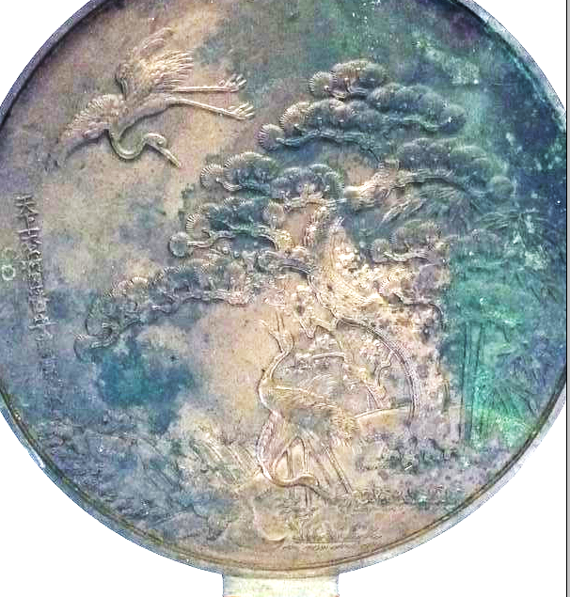

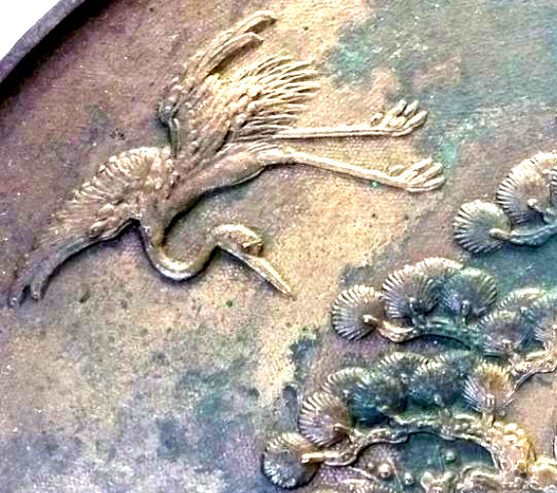

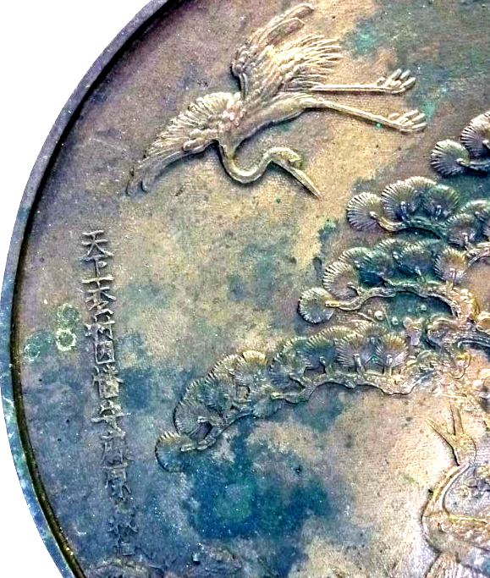

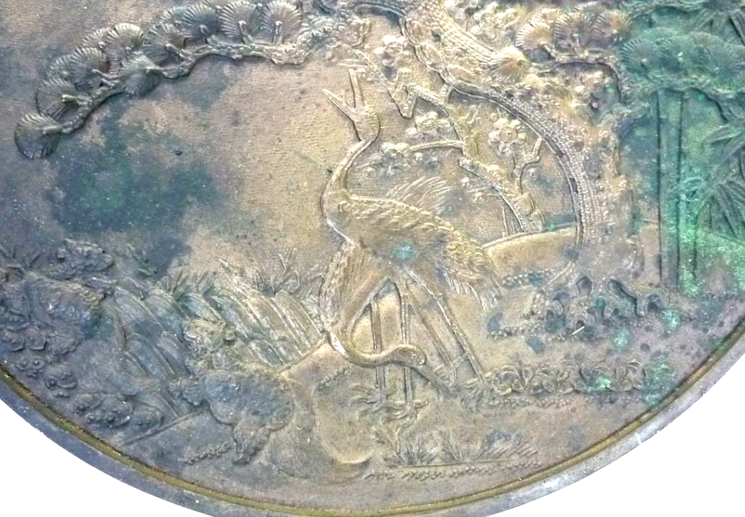

# Dokyo / Kagami mirror 27cm/10.6" diam.

with symbols of felicity such as cranes, pine trees and bamboo trees casted on the back side. Size (approx.) : H38cm/14.9" x 27cm/10.6" in diam.

Net weight (approx.) : 1.36kg/2.9lb

Gross weight (approx.) : 1.5kg/3.3lb